Thameside Wallingford U3A
Brighton Royal Pavilion
Friday 27th March 2020

It will soon be time to dust off those dreary cobwebs and shake off the winter blues!

Come with us on Friday 27th March to visit one of the most fantastic and exotic palaces in the world - Brighton Royal Pavilion. Built by George 4th it portrays all the extravagance of his lifestyle. As soon as you enter you are taken aback by its overwhelming grandeur.

As an added bonus, a loan by the Queen of 120 works of art that were originally commissioned by the Prince Regent, some of which have not been on display for over 170 years have been relocated to the Pavilion while essential building works are carried out at Buckingham Palace.

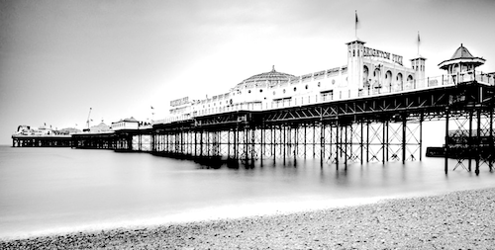
When we arrive in Brighton we will enjoy tea/coffee and a Danish pastry at a local Italian restaurant. We will then have a guided tour of the magnificent rooms after which we will have free time to have lunch and visit the famous "Lanes" antiques area or alternatively have a bracing walk along the prom or even have a stroll on the pier or just simply do your own thing!

Pick up: Wallingford Museum 7:45 am, Crowmarsh Church 7:50 am.
Return approx 6:45 pm depending on traffic.

Included: coach travel with driver's tip, refreshments on arrival, entry and guided tour of Brighton Pavilion. Not included: any other personal expenses.

---------------------------------------------------------------------------------------------------------------
Brighton Royal Pavilion Booking Form
Friday 27th March

Name………………………………… Mobile Phone………………………..

Email………………………………… Landline………………………………

Please reserve…….tickets for me @ £39.00 to include coach hire, admission & gratuities.

Booking and Payment - please mark with an X
……..by cheque, payable to Thameside (Wallingford) U3A. Please include an SAE if you require a receipt - otherwise an email acknowledgement will be sent.
……..by Bank transfer to Sort Code: 309903 Account no: 01234487 reference ‘Brighton’

Pick me up from Wallingford…. or Crowmarsh…..

Organiser: Mike Sedman Harcourt Lodge, St.Lucian's Lane, Wallingford OX10 9ER
01491 825198: ptimtara@googlemail.com

PLEASE NOTE: whether you are paying by credit transfer or by cheque, the completed booking form MUST be sent to the group leader Mike Sedman in order to make your reservation.

