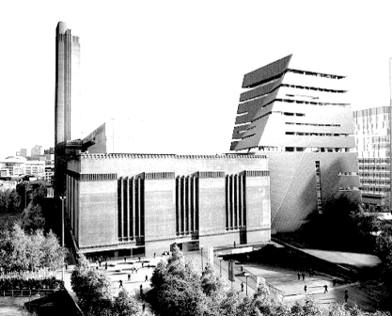
Tate Modern and Tate Britain
Friday 22 November 2019

On this trip we visit two of the Tate art galleries in London with a river trip between them.

First, Tate Modern which was opened in 2000 is housed in the old Bankside Power Station. Along with their permanent collection (featuring, among others, Pablo Picasso, Henri Matisse and Barbara Hepworth). We will have the opportunity to enjoy temporary exhibitions by William Blake and Mark Leckey (at an additional charge).

The “Tate to Tate” ferry, run by mbna Thames Clippers and labeled RB2, goes at approximately half hour intervals from a Jetty directly opposite the gallery. The ferry from Bankside to Millbank will cost £4.80 and timetables for the ferry will be distributed on the coach. Please note that this charge is not included in the cost of this visit.

Tate Britain is the home of British art from 1500 to the present day. Tate Britain holds the largest collection of British art in the world and includes masterpieces by J.M.W. Turner, John Constable and John Everett Millais, as well as contemporary work by Francis Bacon, Lucian Freud and David Hockney among others.

Food (at your own expense) is available in both galleries and at nearby cafes/restaurants, or you may prefer to take sandwiches to have by the river.

Having dropped us at Tate Modern, the coach will collect us from Tate Britain, where there is limited coach parking and so we would please ask you to be ready for departure at 4:00 pm.

Leave Wallingford Library at 8:00 am
Leave Crowmarsh church at 8:10 am

Depart Tate Britain at 4:00 pm to return to Wallingford by about 6:30 pm.

- - - - - - - - - - - - - - - - - - - - - - - - - - - - - -- - - - - - - - - - - - - - -- - - - - - - - - - - - - - -- - - - - -

Name(s) Phone No:

Email Mobile: .

Please reserve ..... place(s) at £ 20

Pick up: …… Wallingford ………. Crowmarsh

Booking and Payment (please indicate with ‘X’):
…… By cheque, payable to THAMESIDE (WALLINGFORD) U3A sent with SAE for confirmation, or request email response, to:
Richard Wooldridge 12 The Mint, Wallingford OX10 0XB
Telephone 01491 834786 E-mail rich.wool@talktalk.net
…… By Bank Transfer
Bank transfer details: Sort code 30-99-03 Account number 01234487 Reference "Tate"

For a paperless application by email, complete the editable version of this form,
save it using your name in the title and send it as an attachment to rich.wool@talktalk.net

Please note: Whether paying by cheque or bank transfer, the information on this registration form MUST be sent to the Outing Leader, in order to make your reservation.

Timetable for the RB2 ferry operated by mbna Thames Clippers.
Your ticket covers only a single journey from Bankside to Millbank.

Dep Bankside Arr Millbank

10.08 10.28
10:38 10:58
11:08 11:28
11:30 11:58
12:08 12:28
12:38 12:58
13:08 13:28
13:38 13:58
14:08 14:28
14:38 14:58
15:08 15:28

Please note that the boats run on time and may even be slightly early!
They do not wait even if you are on the walkway down to the jetty:

